Blueprint Scale
# Source: AI Source: Provided by: [Data Path: Persons Table -> ID Column: 1, Name_En Column: Motasem Essam] -> From: [ChatGPT] on [7/17/2026]
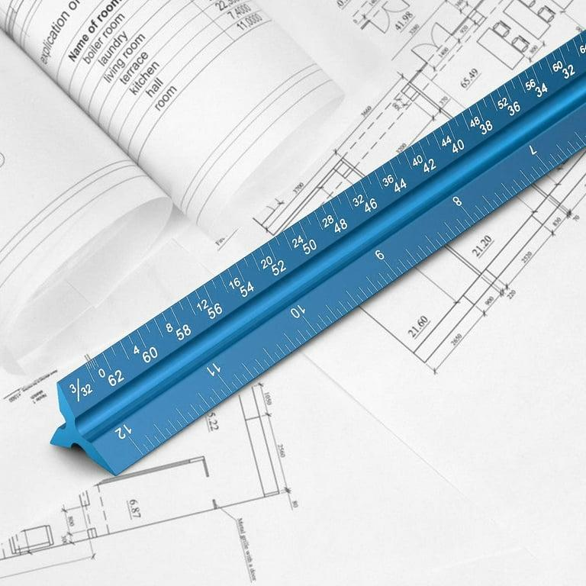
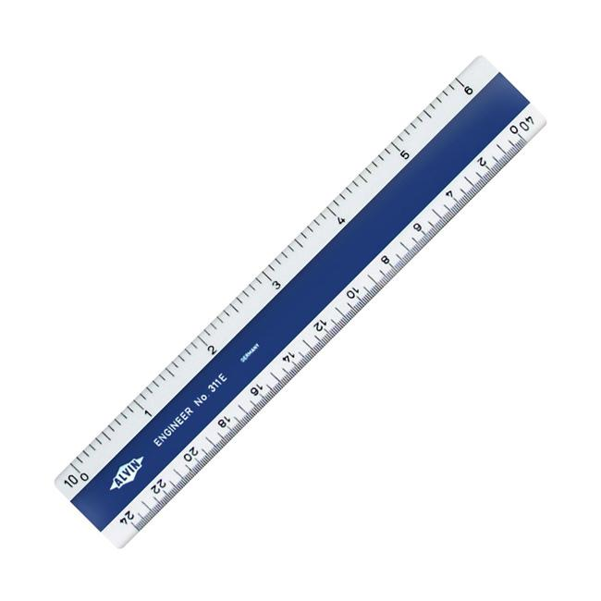
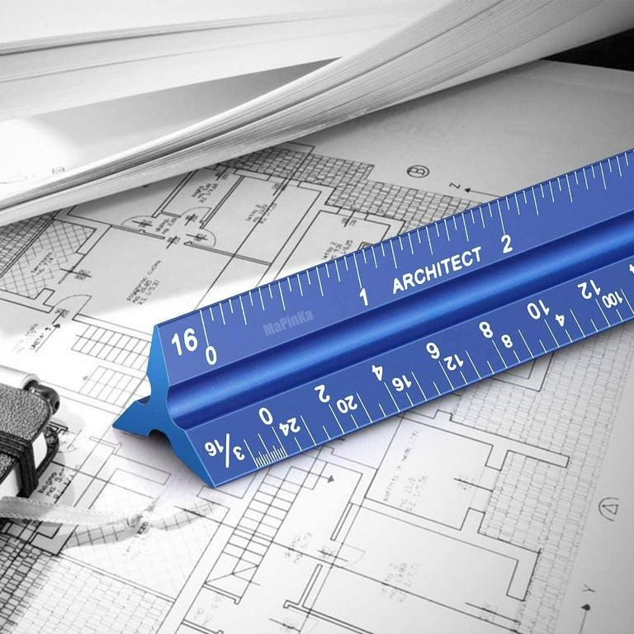
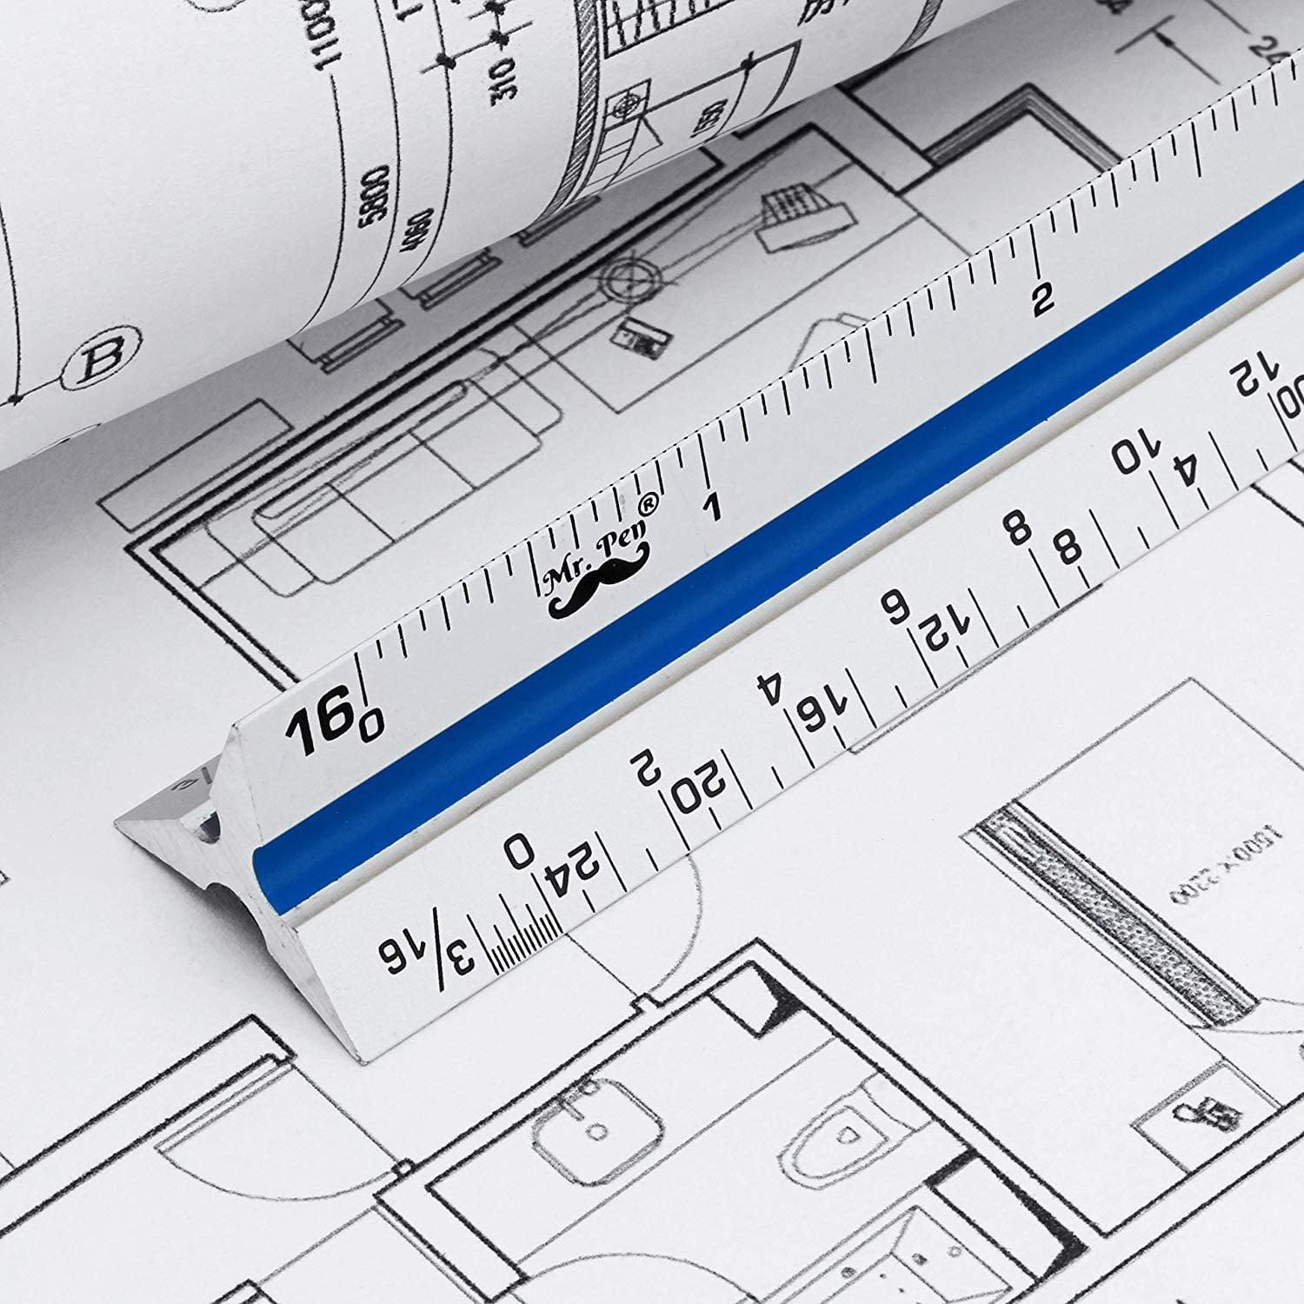
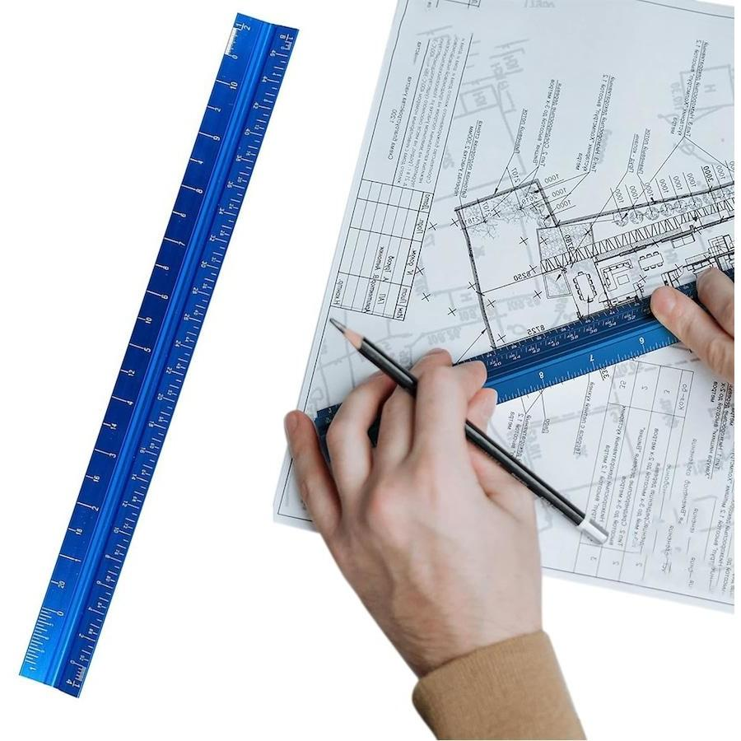
A Blueprint Scale is a specialized measuring scale used to read, interpret, and create architectural, engineering, and construction drawings. It enables accurate conversion between the dimensions shown on a blueprint and the actual dimensions of the real object.
Unlike ordinary rulers, a blueprint scale contains multiple calibrated scales on a single instrument to accommodate different drawing scales.

Purpose
# Source: AI Source: Provided by: [Data Path: Persons Table -> ID Column: 1, Name_En Column: Motasem Essam] -> From: [ChatGPT] on [7/17/2026]
Blueprint scales are used to:
- Measure dimensions on engineering drawings.
- Read architectural plans.
- Convert drawing measurements into actual dimensions.
- Produce accurate technical drawings.
- Verify construction dimensions.
- Support drafting and design work.

Principle
# Source: AI Source: Provided by: [Data Path: Persons Table -> ID Column: 1, Name_En Column: Motasem Essam] -> From: [ChatGPT] on [7/17/2026]
A blueprint scale works by using a fixed proportional ratio between the drawing and the actual object.
$$\text{Scale}=\frac{\text{Drawing Length}}{\text{Actual Length}}$$
Each edge of the blueprint scale represents a different drawing scale.

Types of Blueprint Scales

1. Architect's Scale
# Source: AI Source: Provided by: [Data Path: Persons Table -> ID Column: 1, Name_En Column: Motasem Essam] -> From: [ChatGPT] on [7/17/2026]
Designed primarily for architectural drawings.
Common scales include:
- 1:20
- 1:25
- 1:50
- 1:75
- 1:100
- 1:125
Applications
- Building plans
- Floor plans
- Interior design
- Construction drawings

2. Engineer's Scale
# Source: AI Source: Provided by: [Data Path: Persons Table -> ID Column: 1, Name_En Column: Motasem Essam] -> From: [ChatGPT] on [7/17/2026]
Used for civil and engineering drawings based on decimal scales.
Common scales include:
- 1:10
- 1:20
- 1:30
- 1:40
- 1:50
- 1:60
Applications
- Civil engineering
- Road design
- Utility layouts
- Survey drawings

3. Metric Scale
# Source: AI Source: Provided by: [Data Path: Persons Table -> ID Column: 1, Name_En Column: Motasem Essam] -> From: [ChatGPT] on [7/17/2026]
Uses metric units for technical drawings.
Common scales include:
- 1:5
- 1:10
- 1:20
- 1:50
- 1:100
- 1:200
- 1:500
Applications
- Mechanical engineering
- Product design
- Manufacturing
- Technical drafting

4. Triangular Scale
# Source: AI Source: Provided by: [Data Path: Persons Table -> ID Column: 1, Name_En Column: Motasem Essam] -> From: [ChatGPT] on [7/17/2026]
A three-sided scale containing multiple scales on each face.
Features
- Six to twelve different scales
- Compact design
- Quick scale selection
Applications
- Architects
- Engineers
- Drafting professionals

Common Blueprint Scales
# Source: AI Source: Provided by: [Data Path: Persons Table -> ID Column: 1, Name_En Column: Motasem Essam] -> From: [ChatGPT] on [7/17/2026]
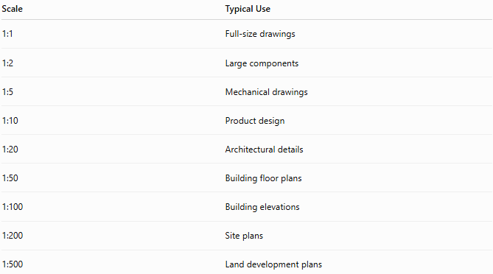
Scale | Typical Use
1:1 | Full-size drawings
1:2 | Large components
1:5 | Mechanical drawings
1:10 | Product design
1:20 | Architectural details
1:50 | Building floor plans
1:100 | Building elevations
1:200 | Site plans
1:500 | Land development plans

Formula
# Source: AI Source: Provided by: [Data Path: Persons Table -> ID Column: 1, Name_En Column: Motasem Essam] -> From: [ChatGPT] on [7/17/2026]
Actual Length
$$\text{Actual Length}=\text{Drawing Length}×\text{Scale Factor}$$

Drawing Length
$$\text{Drawing Length}=\frac{\text{Actual Length}}{\text{Scale Factor}}$$

Example
# Source: AI Source: Provided by: [Data Path: Persons Table -> ID Column: 1, Name_En Column: Motasem Essam] -> From: [ChatGPT] on [7/17/2026]
Blueprint scale:
$$1:50$$
Measured drawing length:
$$6\text{ cm}$$
Actual length:
$$6×50=300\text{ cm} \\ 300\text{ cm}=3\text{ m}$$
Therefore,
6 cm on the blueprint represents 3 m in reality.

Applications
# Source: AI Source: Provided by: [Data Path: Persons Table -> ID Column: 1, Name_En Column: Motasem Essam] -> From: [ChatGPT] on [7/17/2026]
Blueprint scales are used in:
- Architecture
- Civil engineering
- Mechanical engineering
- Structural engineering
- Construction
- Manufacturing
- Urban planning
- Surveying

Advantages
# Source: AI Source: Provided by: [Data Path: Persons Table -> ID Column: 1, Name_En Column: Motasem Essam] -> From: [ChatGPT] on [7/17/2026]
Blueprint scales:
- Improve measurement accuracy.
- Speed up drawing interpretation.
- Support multiple standard scales.
- Reduce calculation errors.
- Simplify technical drafting.

Limitations
# Source: AI Source: Provided by: [Data Path: Persons Table -> ID Column: 1, Name_En Column: Motasem Essam] -> From: [ChatGPT] on [7/17/2026]
Blueprint scales:
- Must match the drawing scale.
- Become inaccurate if drawings are improperly enlarged or reduced.
- Require familiarity with engineering scales.

Sources of Error
# Source: AI Source: Provided by: [Data Path: Persons Table -> ID Column: 1, Name_En Column: Motasem Essam] -> From: [ChatGPT] on [7/17/2026]
Instrument Errors
- Worn scale markings
- Manufacturing inaccuracies

User Errors
- Selecting the wrong scale
- Reading the incorrect graduation
- Incorrect unit conversion

Environmental Errors
- Blueprint distortion due to printing or photocopying
- Paper expansion caused by humidity

Comparison with Other Scales
# Source: AI Source: Provided by: [Data Path: Persons Table -> ID Column: 1, Name_En Column: Motasem Essam] -> From: [ChatGPT] on [7/17/2026]
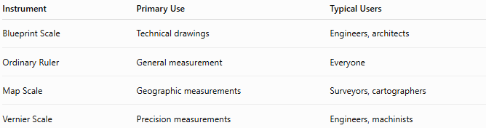
Instrument | Primary Use | Typical Users
Blueprint Scale | Technical drawings | Engineers, architects
Ordinary Ruler | General measurement | Everyone
Map Scale | Geographic measurements | Surveyors, cartographers
Vernier Scale | Precision measurements | Engineers, machinists

Best Practices
# Source: AI Source: Provided by: [Data Path: Persons Table -> ID Column: 1, Name_En Column: Motasem Essam] -> From: [ChatGPT] on [7/17/2026]
- Verify the drawing scale before measuring.
- Use the matching side of the blueprint scale.
- Keep units consistent.
- Avoid measuring distorted or resized drawings.
- Confirm dimensions with drawing notes when available.

Key Points
# Source: AI Source: Provided by: [Data Path: Persons Table -> ID Column: 1, Name_En Column: Motasem Essam] -> From: [ChatGPT] on [7/17/2026]
- A Blueprint Scale is used to measure and interpret technical drawings.
- Common types include:
  - Architect's Scale
  - Engineer's Scale
  - Metric Scale
  - Triangular Scale
- It converts drawing dimensions into actual dimensions accurately.
- It is an essential tool in architecture, engineering, construction, and manufacturing.

Conclusion
# Source: AI Source: Provided by: [Data Path: Persons Table -> ID Column: 1, Name_En Column: Motasem Essam] -> From: [ChatGPT] on [7/17/2026]
A Blueprint Scale is a specialized measuring instrument used to accurately interpret scaled technical drawings and blueprints. By providing multiple standard scales in a single tool, it enables architects, engineers, surveyors, and construction professionals to convert drawing measurements into real-world dimensions efficiently and accurately. It is an indispensable instrument in drafting, design, engineering, and construction projects.

